NETFLIX CLONE
DevOps Project
End-to-End CI/CD Pipeline | Containerization | Kubernetes Orchestration
Infrastructure as Code | Prometheus & Grafana Monitoring

Done by: Sanjeevkumar R
Training: AWS & DevOps, Login 360, Chennai

1)PROJECT OVERVIEW

This project describes the complete rebuild of the Netflix Clone DevOps project in the AWS Mumbai region (ap-south-1)
The Netflix Clone is a React/Vite single-page application that fetches movie and show data from The Movie Database (TMDB) API. The application code was cloned from a public repository, but all DevOps tooling — the Dockerfile, Jenkins pipeline, Kubernetes, Terraform configuration, and monitoring stack was written.

GitHub (Netflix-Clone source code)
|
v
Jenkins (EC2: jenkins-server) --build--> Docker Image
| |
|
| DockerHub (sanjeevnavi/netflix)
| |
v
Terraform (infra as code) Kubernetes Cluster (kubemaster + kubeslave)
| |
v
AWS EC2 Instances Deployment + Service (NodePort 30007)
|

Prometheus + Grafana (monitoring)

2) AWS Infrastructure

EC2 Instances Mumbai-(ap-south-1)
Instance Name | Instance Type | Role | Key Software
Jenkins-docker-net | c7i-flex.large | CI/CD server + Docker build host | Jenkins, Docker, Java JDK
kubemaster | c7i-flex.large | Kubernetes control plane | kubeadm, kubelet, kubectl, Flannel CNI, Prometheus, Grafana
kubeslave | t3.small | Kubernetes worker node | kubeadm, kubelet, container runtime

Security Group (netflix)
Port / Range | Protocol | Purpose
22 | TCP | SSH access
8080 | TCP | Jenkins
6443 | TCP | Kubernetes API server
30000–32767 | TCP | Kubernetes NodePort service range (app + monitoring)
All traffic | All | Unrestricted inter-node communication within the cluster

- Two different instance types were used: c7i-flex. large for the Jenkins and kubemaster nodes (heavier workloads running Jenkins pipelines, Kubernetes control plane, Prometheus, and Grafana simultaneously) and t3. small for kubeslave (lighter work).
- Allocate same security groupg for the three instances.

3 Install Java, Jenkins & Docker

Java installation
sudo apt update -y
sudo apt install openjdk-17-jdk -y
java -version

Jenkins Installation

curl -fsSL https://pkg.jenkins.io/debian-stable/jenkins.io-2026.key \

| sudo gpg --dearmor -o /usr/share/keyrings/jenkins-keyring.gpg

echo "deb [signed-by=/usr/share/keyrings/jenkins-keyring.gpg] \

https://pkg.jenkins.io/debian-stable binary/" \

| sudo tee /etc/apt/sources.list.d/jenkins.list

sudo apt update -y

sudo apt install jenkins -y

sudo systemctl start jenkins

sudo systemctl enable Jenkins

After starting Jenkins, the initial admin password is retrieved and used to unlock the setup wizard,

sudo cat /var/lib/jenkins/secrets/initialAdminPassword

Browser access: http://<jenkins-public-ip>:8080
Installed three required plugins: Pipeline, Git, and Credentials.

Docker Installation on Jenkin server

sudo apt install docker.io -y

sudo systemctl start docker

sudo systemctl enable docker

Allow Jenkins and the ubuntu user to run docker commands

sudo usermod -aG docker jenkins

sudo usermod -aG docker ubuntu

sudo systemctl restart jenkins

sudo systemctl restart docker

DockerHub Credentials
DockerHub credentials were stored in Jenkins' built-in Credentials store with the ID dockerhub-creds.
Application Source
sudo apt install git –y
git clone https://github.com/Aj7Ay/Netflix-Clone.git
cd Netflix-Clone
ls
Dockerfile:
FROM node:18-alpine AS build
WORKDIR /app
COPY package.json yarn.lock ./
RUN yarn install
COPY . .
ARG TMDB_V3_API_KEY
ENV VITE_APP_TMDB_V3_API_KEY=${TMDB_V3_API_KEY}
ENV VITE_APP_API_ENDPOINT_URL="https://api.themoviedb.org/3"

RUN yarn build

FROM nginx:alpine

COPY --from=build /app/dist /usr/share/nginx/html

EXPOSE 80

CMD ["nginx", "-g", "daemon off;"]

Build & Push

sudo docker build --build-arg TMDB_V3_API_KEY=eabc461e565bf9f179666684db8a691f -t sanjeevnavi/netflix:mumbai1 .

sudo docker login -u sanjeevnavi

sudo docker push sanjeevnavi/netflix:mumbai1

Image push into dockerhub.

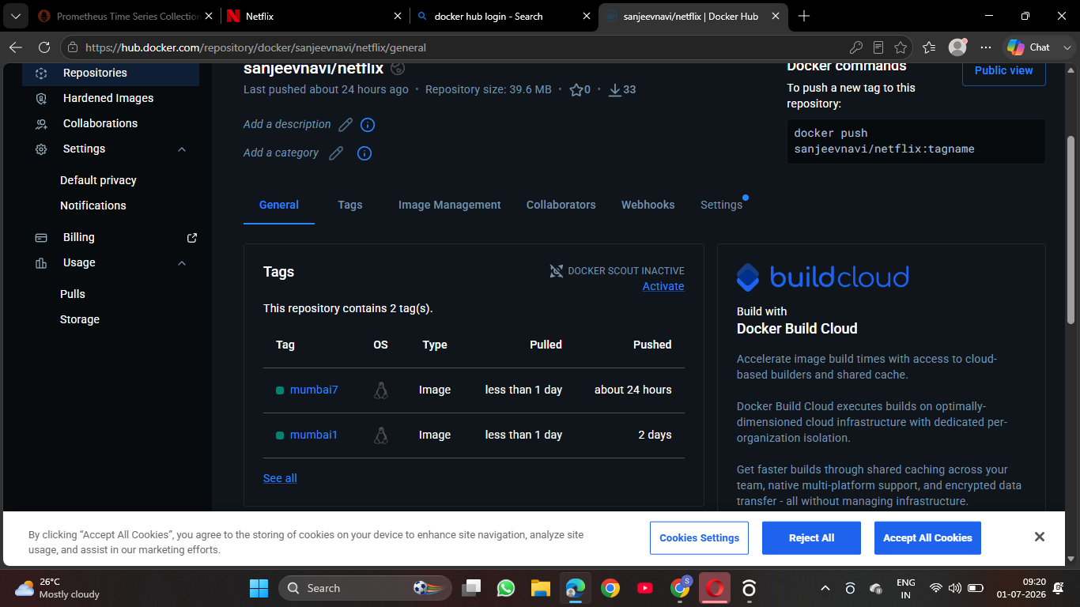

4) Kubernetes Cluster Setup

Installation on both server:
sudo apt-get update -y
sudo apt-get install -y apt-transport-https ca-certificates curl gpg
sudo mkdir -p -m 755 /etc/apt/keyrings
curl -fsSL https://pkgs.k8s.io/core:/stable:/v1.30/deb/Release.key | sudo gpg --dearmor -o /etc/apt/keyrings/kubernetes-apt-keyring.gpg
echo 'deb [signed-by=/etc/apt/keyrings/kubernetes-apt-keyring.gpg] https://pkgs.k8s.io/core:/stable:/v1.30/deb/ /' | sudo tee /etc/apt/sources.list.d/kubernetes.list
sudo apt-get update -y
sudo apt-get install -y kubelet kubeadm kubectl
sudo apt-mark hold kubelet kubeadm kubectl
sudo swapoff -a
sudo sed -i '/ swap / s/^(.*)$/#\1/g' /etc/fstab
free -m
sudo tee /etc/modules-load.d/k8s.conf <<EOF
overlay
br_netfilter
EOF
sudo modprobe overlay
sudo modprobe br_netfilter
sudo tee /etc/sysctl.d/kubernetes.conf<<EOF
net.bridge.bridge-nf-call-ip6tables = 1
net.bridge.bridge-nf-call-iptables = 1
net.ipv4.ip_forward = 1
EOF
sudo sysctl --system
sudo apt install -y curl gnupg2 software-properties-common apt-transport-https ca-certificates
curl -fsSL https://download.docker.com/linux/ubuntu/gpg | sudo gpg --dearmor -o /etc/apt/trusted.gpg.d/docker-archive-keyring.gpg
sudo add-apt-repository "deb [arch=amd64] https://download.docker.com/linux/ubuntu $(lsb_release -cs) stable"
sudo apt update -y
sudo apt install -y containerd.io
sudo mkdir -p /etc/containerd
sudo containerd config default|sudo tee /etc/containerd/config.toml
sudo sed -i 's/SystemdCgroup \= false/SystemdCgroup \= true/g' /etc/containerd/config.toml
sudo systemctl restart containerd
sudo systemctl enable containerd
systemctl status containerd
Master Only config:
kubeadm init --apiserver-advertise-address=172.31.3.229--pod-network-cidr=10.244.0.0/16
mkdir -p $HOME/.kube
sudo cp -i /etc/kubernetes/admin.conf $HOME/.kube/config
sudo chown $(id -u):$(id -g) $HOME/.kube/config

Install the Flannel Network Plugin (kubemaster only)
kubectl apply -f https://github.com/flannel-io/flannel/releases/latest/download/kube-flannel.yml
Worker node config:
sudo kubeadm join 172.31.80.226:6443 --token muqs6d.bp20sen8g8hvrun3 \
--discovery-token-ca-cert-hash sha256:c72de18cda182154509a2db27085ccd3d7a692f31dbbcb38828ed0c878310da5 New

Verification:
kubectl get nodes ---- to get nodes

Application Deployment

apiVersion: apps/v1

kind: Deployment

metadata:

name: netflix-app

labels:

app: netflix-app

spec:

replicas: 2

selector:

matchLabels:

app: netflix-app

template:

metadata:

labels:

app: netflix-app

spec:

containers:

- name: netflix-app

image: sanjeevnavi/netflix:mumbai1

ports:

- containerPort: 80

Service.yaml

apiVersion: v1

kind: Service

metadata:

name: netflix-service

spec:

type: NodePort

selector:

app: netflix-app

ports:

- port: 80

targetPort: 80

nodePort: 30008
The application was confirmed live and accessible in a browser at http://<3.110.48.7>:30008.

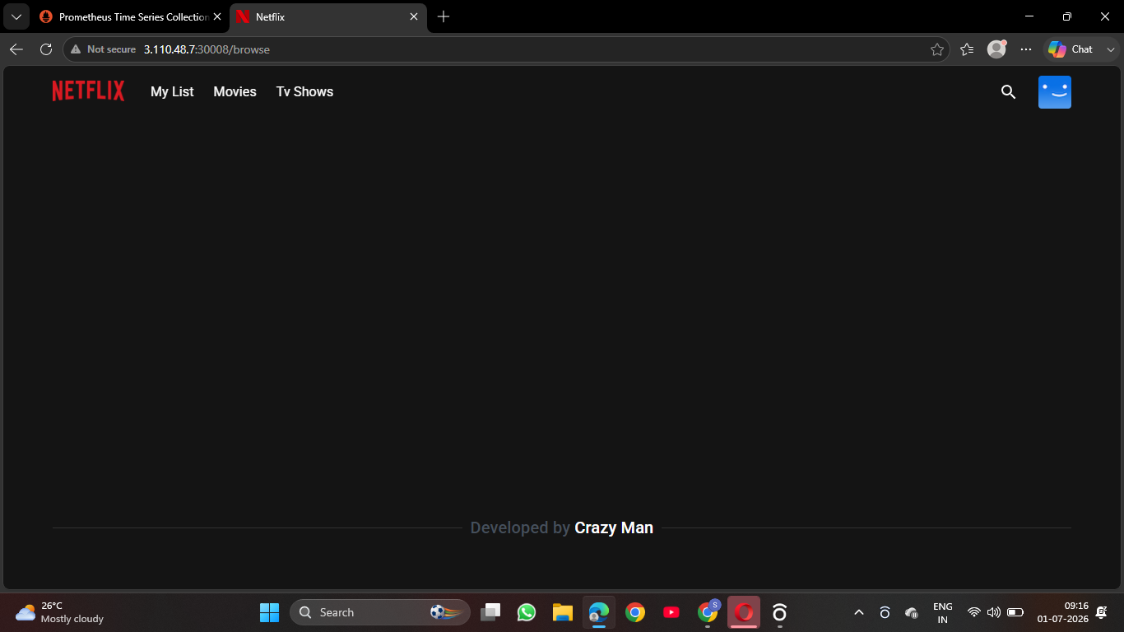

5) Jenkins CI/CD Pipeline Setup

Before we build, test and deploy should has a manual process, on further it should deploy at every commit

Install the three plugins in credential save detail as in table
Kind | Username with password
Username | sanjeevnavi
Password | DockerHub password
ID | dockerhub-creds

Pipeline Job

New Item → name: netflix-clone-pipeline → type: Pipeline → Pipeline section → Pipeline script.

pipeline {

agent any

environment {

DOCKERHUB_CREDENTIALS = credentials('dockerhub-creds')

IMAGE_NAME = 'sanjeevnavi/netflix'

TMDB_API_KEY = 'eabc461e565bf9f179666684db8a691f'

}

stages {

stage('Clone Repository') {

steps {

git branch: 'main', url: 'https://github.com/Aj7Ay/Netflix-Clone.git'

}

}

stage('Add Custom Dockerfile') {

steps {

writeFile file: 'Dockerfile', text: '''FROM node:18-alpine AS build

WORKDIR /app

COPY package.json yarn.lock ./

RUN yarn install

COPY . .

ARG TMDB_V3_API_KEY

ENV VITE_APP_TMDB_V3_API_KEY=${TMDB_V3_API_KEY}

ENV VITE_APP_API_ENDPOINT_URL="https://api.themoviedb.org/3"

RUN yarn build

FROM nginx:alpine

COPY --from=build /app/dist /usr/share/nginx/html

EXPOSE 80

CMD ["nginx", "-g", "daemon off;"]

'''

}

}

stage('Build Docker Image') {

steps {

sh "docker build --build-arg TMDB_V3_API_KEY=${TMDB_API_KEY} -t ${IMAGE_NAME}:mumbai${BUILD_NUMBER} ."

}

}

stage('Login to DockerHub') {

steps {

sh "echo ${DOCKERHUB_CREDENTIALS_PSW} | docker login -u ${DOCKERHUB_CREDENTIALS_USR} --password-stdin"

}

}

stage('Push Docker Image') {

steps {

sh "docker push ${IMAGE_NAME}:mumbai${BUILD_NUMBER}"

}

}

}

post {

success { echo 'Pipeline completed successfully! Image pushed to DockerHub.' }

failure { echo 'Pipeline failed. Check the logs above.' }

}

}

For every automate it increase with a tag

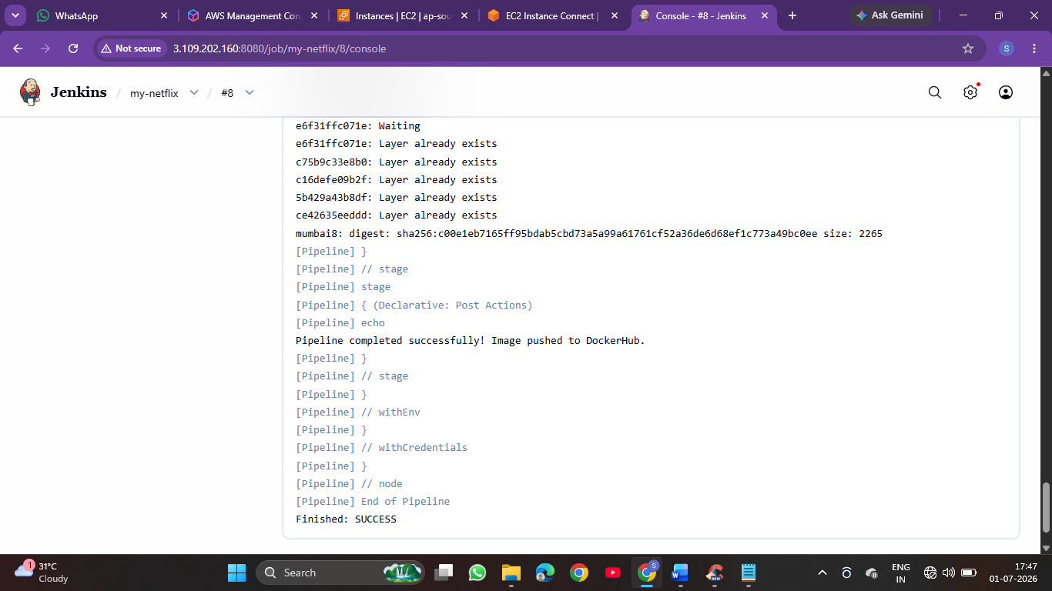

6) TERRAFORM

Installation

wget -O- https://apt.releases.hashicorp.com/gpg | sudo gpg --dearmor -o

/usr/share/keyrings/hashicorp-archive-keyring.gpg

echo "deb [signed-by=...] https://apt.releases.hashicorp.com $(lsb_release -cs) main" | sudo tee /etc/apt/sources.list.d/hashicorp.list

sudo apt update && sudo apt install terraform -y

Configuration Files
Three files were created in ~/terraform-netflix-mumbai/ on Jenkins-docker-net:
- Provider.tf
terraform {
required_providers {
aws = {
source = "hashicorp/aws"
version = "~> 5.0"
}
}
}

provider "aws" {
region = var.aws_region
}
- Variables.tf
variable "aws_region" {
default = "ap-south-1"
}

variable "instance_type" {
default = "c7i-flex.large"
}

variable "key_name" {
default = "netflix"
}

variable "ami_id_jenkins" {
default = "ami-01a00762f46d584a1"
}

variable "ami_id_k8s" {
default = "ami-006f82a1d5a27da54"
}
- main.tf
resource "aws_security_group" "netflix_sg" {
name = "netflix-sg-mumbai-tf"
description = "Security group for Netflix clone project - Mumbai"

ingress {
from_port = 22
to_port = 22
protocol = "tcp"
cidr_blocks = ["0.0.0.0/0"]
}

ingress {
from_port = 8080
to_port = 8080
protocol = "tcp"
cidr_blocks = ["0.0.0.0/0"]
}

ingress {
from_port = 6443
to_port = 6443
protocol = "tcp"
cidr_blocks = ["0.0.0.0/0"]
}

ingress {
from_port = 30000
to_port = 32767
protocol = "tcp"
cidr_blocks = ["0.0.0.0/0"]
}

ingress {
from_port = 0
to_port = 0
protocol = "-1"
self = true
}

egress {
from_port = 0
to_port = 0
protocol = "-1"
cidr_blocks = ["0.0.0.0/0"]
}

tags = {
Name = "netflix-sg-mumbai-tf"
}
}
resource "aws_instance" "jenkins_server" {
ami = var.ami_id_jenkins
instance_type = var.instance_type
key_name = var.key_name
vpc_security_group_ids = ["sg-0484ffbdebc086415"]

tags = {
Name = "Jenkins-docker-net"
}
}

resource "aws_instance" "kubemaster" {
ami = var.ami_id_k8s
instance_type = var.instance_type
key_name = var.key_name
vpc_security_group_ids = ["sg-0484ffbdebc086415"]

tags = {
Name = "kubemaster"
}
}

resource "aws_instance" "kubeslave" {
ami = var.ami_id_k8s
instance_type = var.instance_type
key_name = var.key_name
vpc_security_group_ids = ["sg-0484ffbdebc086415"]

tags = {
Name = "kubeslave"
}
}

Validation Result

terraform init

terraform validate

terraform plan
The plan correctly shows 3 instances to add (matching the real infrastructure), confirming the Terraform code accurately represents what was built manually. The plan output was saved to plan_output.txt and pushed to GitHub.

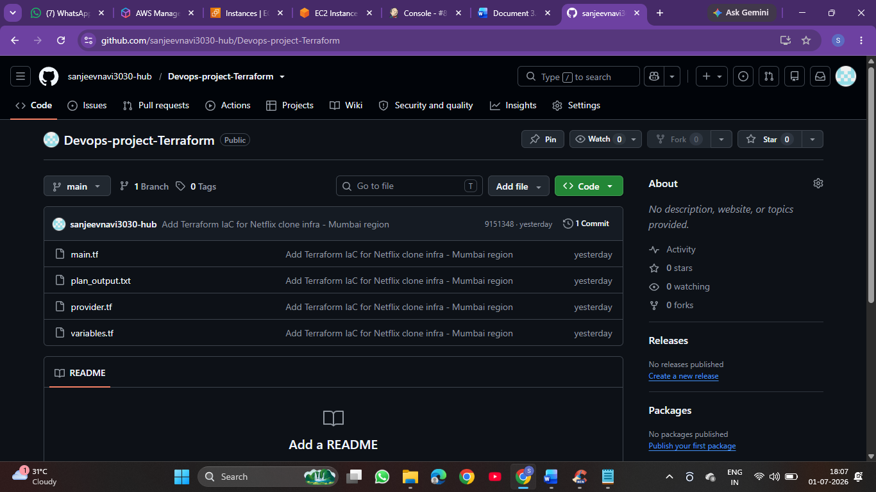

7) Monitoring (Prometheus & Grafana)

Both Prometheus and Grafana were deployed inside the Kubernetes cluster using YAML manifests.
Creates a folder

mkdir ~/monitoring

cd ~/monitoring

kubectl create namespace monitoring

create a rbac service yaml file:

apiVersion: v1

kind: ServiceAccount

metadata:

name: prometheus

namespace: monitoring

---

apiVersion: rbac.authorization.k8s.io/v1

kind: ClusterRole

metadata:

name: prometheus

rules:

- apiGroups: [""]

resources: ["nodes", "nodes/proxy", "nodes/metrics", "services", "endpoints", "pods"]

verbs: ["get", "list", "watch"]

- apiGroups: ["extensions"]

resources: ["ingresses"]

verbs: ["get", "list", "watch"]

- nonResourceURLs: ["/metrics"]

verbs: ["get"]

---

apiVersion: rbac.authorization.k8s.io/v1

kind: ClusterRoleBinding

metadata:

name: prometheus

roleRef:

apiGroup: rbac.authorization.k8s.io

kind: ClusterRole

name: prometheus

subjects:

- kind: ServiceAccount

name: prometheus

namespace: monitoring

Then create a config yaml for Prometheus

apiVersion: v1

kind: ConfigMap

metadata:

name: prometheus-config

namespace: monitoring

data:

prometheus.yml: |

global:

scrape_interval: 15s

scrape_configs:

- job_name: 'kubernetes-pods'

kubernetes_sd_configs:

- role: pod

relabel_configs:

- source_labels: [__meta_kubernetes_pod_annotation_prometheus_io_scrape]

action: keep

regex: true

- job_name: 'kubernetes-nodes'

kubernetes_sd_configs:

- role: node

scheme: https

tls_config:

ca_file: /var/run/secrets/kubernetes.io/serviceaccount/ca.crt

insecure_skip_verify: true

bearer_token_file: /var/run/secrets/kubernetes.io/serviceaccount/token

last create a deployment yaml of Prometheus

apiVersion: apps/v1

kind: Deployment

metadata:

name: prometheus

namespace: monitoring

spec:

replicas: 1

selector:

matchLabels:

app: prometheus

template:

metadata:

labels:

app: prometheus

spec:

serviceAccountName: prometheus

containers:

- name: prometheus

image: prom/prometheus:latest

args:

- "--config.file=/etc/prometheus/prometheus.yml"

ports:

- containerPort: 9090

volumeMounts:

- name: config-volume

mountPath: /etc/prometheus/

volumes:

- name: config-volume

configMap:

name: prometheus-config

---

apiVersion: v1

kind: Service

metadata:

name: prometheus-service

namespace: monitoring

spec:

type: NodePort

selector:

app: prometheus

ports:

- port: 9090

targetPort: 9090

nodePort: 30900

After kubectl get pods -n monitoring to check Prometheus is running

Grafana:

Create a config yaml for Grafana

apiVersion: v1

kind: ConfigMap

metadata:

name: grafana-datasources

namespace: monitoring

data:

datasource.yaml: |

apiVersion: 1

datasources:

- name: Prometheus

type: prometheus

access: proxy

url: http://prometheus-service.monitoring.svc.cluster.local:9090

isDefault: true

editable: true

then create a deployment yaml of Grafana

apiVersion: apps/v1

kind: Deployment

metadata:

name: grafana

namespace: monitoring

spec:

replicas: 1

selector:

matchLabels:

app: grafana

template:

metadata:

labels:

app: grafana

spec:

containers:

- name: grafana

image: grafana/grafana:latest

ports:

- containerPort: 3000

env:

- name: GF_SECURITY_ADMIN_PASSWORD

value: "admin123"

- name: GF_ANALYTICS_REPORTING_ENABLED

value: "false"

- name: GF_ANALYTICS_FEEDBACK_LINKS_ENABLED

value: "false"

volumeMounts:

- name: datasource-config

mountPath: /etc/grafana/provisioning/datasources

volumes:

- name: datasource-config

configMap:

name: grafana-datasources

---

apiVersion: v1

kind: Service

metadata:

name: grafana-service

namespace: monitoring

spec:

type: NodePort

selector:

app: grafana

ports:

- port: 3000

targetPort: 3000

nodePort: 30300

Confirmed Working State
The final monitoring was confirmed by;
- kubectl get pods -n monitoring showed both pods at 1/1 Running, 0 restarts, stable over time.
- curl -I http://localhost:30900 and curl -I http://localhost:30300 both returned HTTP/1.1 302 Found instantly.
- Prometheus query `up` executed via phone browser returned 2 result series (kubemaster and kubeslave) with value 1 — both nodes confirmed UP and successfully scraped.
- Grafana dashboard created with the `up` query showing both nodes at value 1, saved as 'Kubernetes node status'.
- Prometheus automatically provisioned on pod start by ConfigMap.

